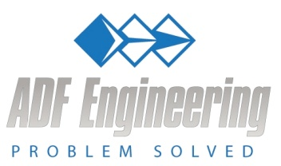

Instructions for Registering and Completing an On-Line Employment Application

Registration: Please go to our website (www.adfengineering.com ) and pull down the sub-menu under the “Careers” tab and click on “Open Positions”. Then, click on the position for which you are applying. If the position you are interested in is not listed, then click on “Submit Application for a Non-Listed Position” choice. At this step, you will be registering rather than filing out an application. This will get you into our applicant tracking system.

On-line Application: Please complete the interactive application by clicking on the “Application” link at the bottom of the “Open Positions” page. The Employment Application is a form field .pdf document. If you are using a Mac, you may have to perform some additional steps for the form to retain the information you fill in after you submit the document. Apparently there are some known incompatibility issues between Macs and this type of document.

Alternatively, just follow this link to the Employment Application:

http://adfengineering.com/careers/ADF%20Employment%20Application.pdf

Once you have located the Employment Application, you must carefully follow the steps below to ensure the data you supply remains saved with the completed document you email:

1. Open web document but DO NOT fill in any data as the data will not be saved.

2. Save the BLANK document to your computer by right clicking your mouse and selecting the “save as” command.

3. Give the blank application document a name and a location you can remember (such as “blank ADF application”.)

4. Close the document you just saved.

5. Go to the local copy you just created and re-open it.

6. Resave the document giving it a new name (such as “completed ADF application”).

7. Fill in the form fields and resave the document using the “save” command using the new name you created in step 6.

8. Send the file as an attachment and email it to HR@adfengineering.com.

If you have any problems or questions, please email David Stanforth at dstanforth@adfengneering.com or call 937.847.2700. Thank you for your interest in working at ADF Engineering.

Y:\ADF HR\Recruiting Firms\Instructions for Registering and Completing an On Line Application.docx

